Annex

Commemorative T-shirt Presented by SF&OC
Reply slip

Attn : Secretariat, SF&OC
Email : secretariat@hkolympic.org

Design of the commemorative T-shirt
(Front) (Back)
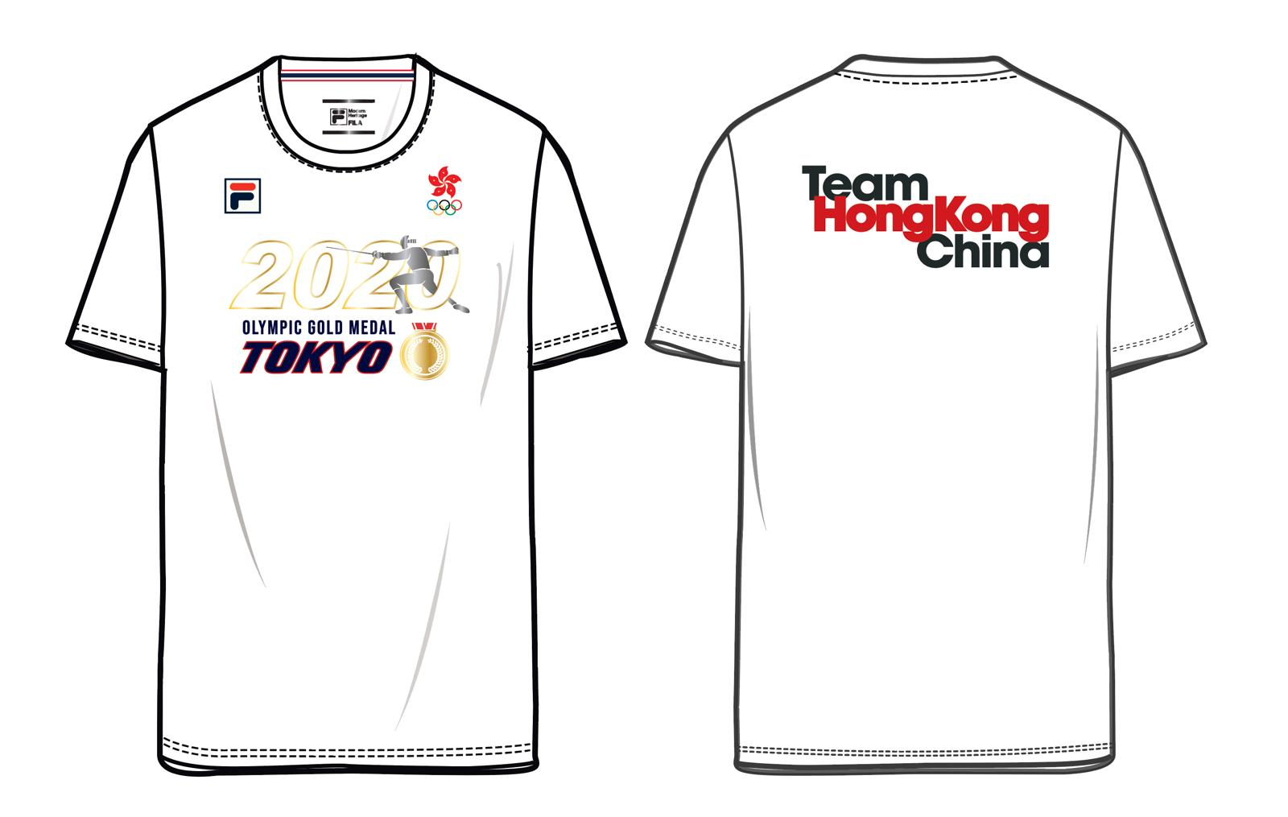

Size chart
Please indicate your preference and return by email on or before 10 January 2023.
 | Size
 | XS | S | M | L | XL | 2XL
Bust | 98 cm | 102 cm | 106 cm | 110 cm | 114 cm | 119 cm
Waist | 98 cm | 102 cm | 106 cm | 110 cm | 114 cm | 119 cm
Length | 65 cm | 67 cm | 69 cm | 71 cm | 73 cm | 75 cm
Your size preference: (Please in the column as appropriate)

Name | :
Post Title | :
Bureau/Department | :
Contact Person | :
Contact No. | :

